**Computer Architecture Practice - COM307P**

**Lab - 7**

**ALU**

**Done by : N Sree Dhyuti - CED19I027**

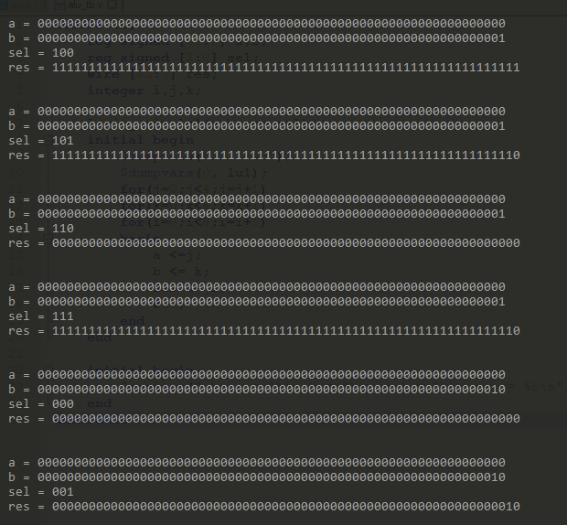

**THE END**